PROJECT PROPOSAL

1. **Major Area**Smart town/city  
   Natural Language Processing and Business

# Problem Statement

Create an Al-powered sentiment analysis solution specialized in interpreting emotions within social media content, empowering individuals and organizations to manage their online reputation and perception effectively.

# Total Cost

Rough Total Cost Estimate:

$5 (EC2) + $10 (RDS) + $0.50 (Route 53) = $15.50 per month.

# College Code & College Name

2116

Rajalakshmi Engineering College, Thandalam

# Guide Name, Designation, Mobile No. & Email id

Name: Dr.K.Ananthajothi

Designation: Associate Professor, Department of Computer Science and Engineering Phone Number: +91 9994075769

Email Id: [ananthajothi.k@rajalakshmi.edu.in](mailto:ananthajothi.k@rajalakshmi.edu.in)

# Student Team details:

1) Reg No: 2116210701168

Name: Muhammed Jazil

Branch: Computer Science and Engineering Mobile No: 9497336000

Email id: [210701168@gmail.com](mailto:210701168@gmail.com) 2) Reg No: 2116210701184

Name: Nitish M

Branch: Computer Science and Engineering Mobile No: 7550004054

Email id: [210701184@rajalakshmi.edu.in](mailto:210701184@rajalakshmi.edu.in)

# Project Summary:

**NUTRIVA is an AI-enabled Sentiment Analysis Tool for Affective Computing, Responsive Insights, and Empowering Individuals.**

With the advancement in the digital landscape and seamless connection between people around the globe, the social media landscape has become an important part of marketing and business strategies of all sizes. It allows the companies to directly interact with the targeted audience and customers of all ages. It helps companies to build brand awareness and ensure customer loyalty. It ensures customers are constantly engaged with them and helps get valuable feedback and get to know their sentiments and insights, to help the business grow, tailor, and modify the products and business according to customer needs. The "AI-Powered Sentiment Analysis Solution for Social Media Content" project aims to develop a compact yet effective tool tailored for individuals and small-scale organizations to manage their online reputation more efficiently. By harnessing the capabilities of natural language processing (NLP) and machine learning algorithms, this solution promises to interpret emotions expressed in social media posts with precision. The project begins with the collection of a small but diverse dataset from popular platforms like Twitter, Facebook, and Instagram. Each post will be meticulously annotated with sentiment labels to facilitate supervised learning. Subsequently, the collected data undergoes preprocessing to remove noise and convert it into a format suitable for analysis. Features extracted from this preprocessed data will capture essential semantic information necessary for sentiment analysis. The project will then explore various machine learning models, including Support Vector Machines (SVM), or basic Recurrent Neural Networks (RNNs), to determine the most suitable approach for sentiment classification. Following model selection, rigorous training on the annotated dataset will enable the model to discern patterns associated with different sentiment classes. Finally, the solution's performance will be evaluated using standard metrics like accuracy, precision, recall, and F1-score, ensuring its reliability in real-world applications. Through its intuitive user interface and seamless deployment on cloud platforms, this sentiment analysis tool promises to empower users with actionable insights to effectively manage their online presence.

# Proposed solution with methodology

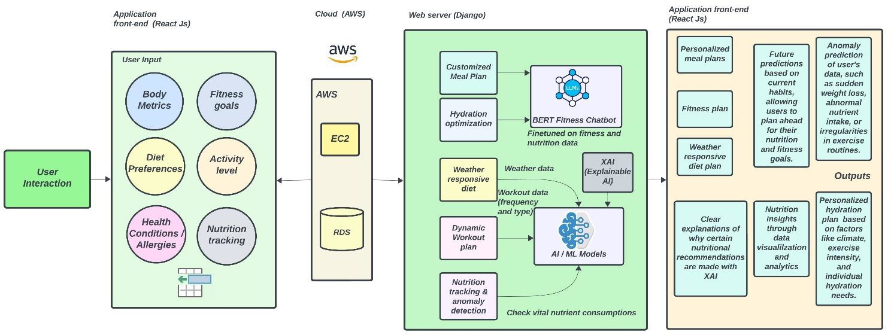

We offer a web application for a fitness analyzer that uses AI. Our application, which is hosted on the AWS cloud, combines React.js on the front end with Django on the back end to provide a stable and simple user experience. Users provide our application with a rich set of data that

allows it to customize recommendations based on their input regarding body metrics, fitness goals, diet preferences, activity level, health conditions, and allergies.

Our application processes the data for predictive analysis using AI and ML models, offering weather-responsive diet recommendations, personalized meals, and dynamic exercise schedules in addition to hydration optimization. The application uses sophisticated algorithms to guarantee accuracy and dependability in its nutrition tracking and anomaly detection features. A fitness and nutrition-focused BERT-based chatbot enhances user interactions by offering prompt and perceptive responses.

with each recommendation being supported by Explainable AI (XAI), increasing user confidence. With the help of predictive analytics, users can make future plans and gain knowledge about upcoming fitness and food trends. Users who receive anomaly predictions are made aware of possible health problems, encouraging a proactive approach to wellbeing. Through user-friendly data visualizations and analytics, the application also offers nutrition insights, enabling users to efficiently monitor their progress.

1. **Workplan / time schedule indicating the project milestone** Week 1: Requirement Analysis and Defining System Features and Functionalities. Week 2: Design Database Schema, Back-end API, Create Wireframes for Frontend

Week 3-4: Set Up Django Project, Implement Database Models, Develop API Endpoints for User Input Handling

## Milestone 1: Backend development

Week 4-6: Train and optimize AI/ML models along with BERT-based chatbot and XAI.

## Milestone 2: AI/ML Module completion

Week 7-8: Develop Front end components for seamless user interfaces with React js and connect them to the backend API

## Milestone 3: Front-end development

Week 9: User testing and feedback optimization

Week 10-12: Pending features/functionalities implementation which is missed (if any) and Deployment

**Milestone 4: Project completion**

# Plan of action for implementation

Define System Features and Functionalities

## Backend :

Design Database Schema Set Up Django Project Implement Database Models

Develop API Endpoints for User Input Handling Gather and preprocess data for AI/ML models Train and Integrate AI/ML Models

Optimize the models

Implement BERT-based chatbot and XAI

## Frontend:

Set Up React.js Project

Implement User Interface Components Connect Frontend to Backend APIs Design and Implement User Input Forms **Testing**:

Testing the user interfaces and functionalities with the robot framework Fetching suggestions and implementing them from some beta users **Deployment**:

Set Up AWS EC2 Instances Configure AWS RDS for Database Deploy Django Application on EC2

# List of facilities available in the college to develop the prototype

GPU-enabled high-performance computer for AI/ML model training and optimization.

# Details of financial assistance required

Amazon EC2: $0.005 per additional IP address

Amazon RDS: $0.095 per GB-month. Snapshot export pricing starts at $0.010 per GB of snapshot size.

Domain names (Route 53): $0.50 per month

# Expected outcome/results

This project will result in a smart fitness tool that promotes people's health. This user- friendly web application allows users to track their nutrition, make customized meal plans, and get exercise recommendations. To deliver personalized recommendations, the app takes into account variables like user preferences, medical conditions, and even the local temperature. It comes with a helpful chatbot that offers quick advice on diet and exercise. Additionally, the tool alerts users to potential problems by keeping an eye out for any odd changes in health data, such as abrupt weight loss. Users can make plans for a healthy lifestyle in advance with the help of precise explanations and future projections. The app makes it easy for users to monitor their progress and stay on top of their fitness goals by visualizing data over time.